useRef Hook:

* What’s useRef?

1. It created a reference and used in functional component.
2. Call useRef at the top level of your component to declare a ref.
3. It can be **used to access a DOM element directly**, means,generallywe want to let React handle all DOM manipulation. But there are some instances where useRef can be used without causing issues.
4. It allows you **to persist values between renders**, means, if the state get changed or the component get re-render, the **value stored with useRef doesn’t change.**
5. It is a React Hook that lets you **reference a value** that’s **not needed for rendering.**

* Implementation:

Calling const **reference** = useRef(initialValue) with the initial value returns a special object named **reference**. The reference object has a property current: you can use this property to read the reference value reference.current, or update reference.current = newValue. **When you change the ref.current property, React does not re-render your component.** On the next renders, useRef will return the same object. React is not aware of when you change it because a ref is a plain JavaScript object.

* There are 2 rules to remember about references:

1. The value of the reference is *persisted* (remains unchanged) between component re-renderings.
2. Updating a reference *doesn't trigger a component re-rendering*.

* Differences between refs and state:

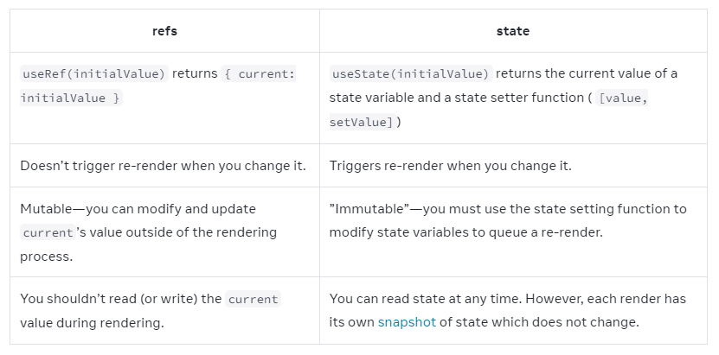

* **Pitfall:**

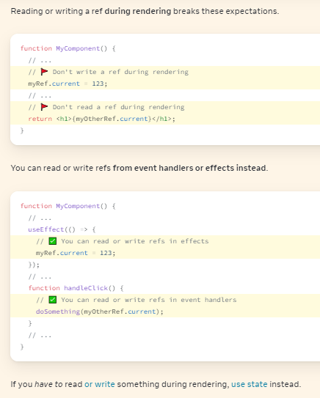

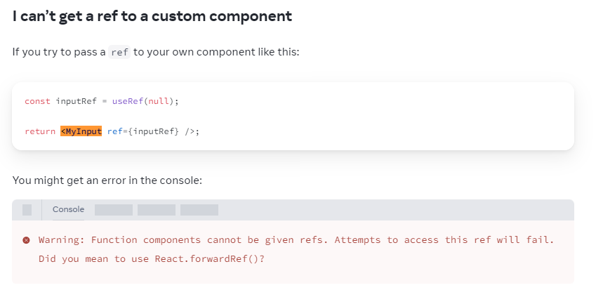

To fix this issue, you must **wrap it in** [**forwardRef**](https://react.dev/reference/react/forwardRef)**.**

* Examples:

**Click Counter:**

import { useRef } from 'react';

export default function Counter() {

let ref = useRef(0);

function handleClick() {

ref.current = ref.current + 1;

alert('You clicked ' + ref.current + ' times!');

}

return (

<button onClick={handleClick}>

Click me!

</button>

);

}

**Focusing a Text:**

import { useRef } from 'react';

export default function Form() {

const inputRef = useRef(null);

function handleClick() {

inputRef.current.focus();

}

return (

<>

<input ref={inputRef} />

<button onClick={handleClick}>

Focus the input

</button>

</>

);

}

**Exposing a ref to your own component:**

import { forwardRef, useRef } from 'react';

const MyInput = forwardRef((props, ref) => {

return <input {...props} ref={ref} />;

});

export default function Form() {

const inputRef = useRef(null);

function handleClick() {

inputRef.current.focus();

}

return (

<>

<MyInput ref={inputRef} />

<button onClick={handleClick}>

Focus the input

</button>

</>

);

}

**Change the style of an element with useRef :**

import React, { useRef } from 'react';  
  
const StyleChangeComponent = () => {  
 const divRef = useRef(null);  
  
 const handleColorChange = () => {  
 divRef.current.style.backgroundColor = 'lightblue';  
 };  
  
 return (  
 <div ref={divRef}>  
 <p>This is a div element whose style can be changed.</p>  
 <button onClick={handleColorChange}>Change Color</button>  
 </div>  
 );  
};

**Changing input value with useRef:**

import React, { useRef } from 'react';  
  
const InputChangeComponent = () => {  
 const inputRef = useRef(null);  
  
 const handleChangeValue = () => {  
 inputRef.current.value = 'New Value';  
 };  
  
 return (  
 <div>  
 <input ref={inputRef} type="text" />  
 <button onClick={handleChangeValue}>Change Input Value</button>  
 </div>  
 );  
};

**🔗 Connect with Me:  
🌐 LinkedIn: https://www.linkedin.com/in/priya-bagde  
📂 GitHub : https://github.com/priya42bagde  
💻 LeetCode : https://leetcode.com/priya42bagde/  
🎥 YouTube Channel : https://youtube.com/channel/UCK1_Op30_pZ1zBs9l3HNyBw (Priya Frontend Vlogz)**